**Software requirements specifications (SRS) for Pet Shop Catalog**

1. **Introduction  
   1.1 Purpose**

The main purpose of the system is to display information and comments on animals in a pet shop.

* 1. **Scope**
     1. The system will have a database that can hold animal’s information
     2. The system will display the information to the user.
     3. The system will allow users to browse the catalog, look at individual animals and leave comments.
     4. The system will count the amount of comments per animal and display the top 2 on the frontpage.
     5. The system will allow the user to narrow the shown animals according to their category.
     6. The system will allow editing all of the individual animal’s field.
     7. The system will allow adding new animals and deleting existing animals.

1. **Overall description   
   2.1** **Product Perspective**  
   The system is comprised of 3 components. The first is the database which holds a collection of animals, categories and comments. The second will be the server which holds all the systems functionality, connecting the 3 components of the system. The third will be the UI – a website which displays the catalog to the user and receives his input. The website has a section for regular users and an administrator page.  
   (the system will not have a validation process of users as we have yet to cover this chapter in our studies)
2. **System Features**
   1. **Product Functions**
      1. 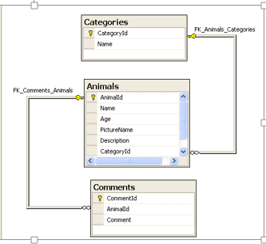The database will have the following structure:
      2. Upon startup the system will load initial animals to the database.
      3. The system will connect a database specified in an external config file (appsettings.json)
      4. Add animal - the system will allow creating new animals and add them to the database.
      5. Edit Animal - the system will allow editing existing animals and save the changes to the database.
      6. Delete animal – the system will allow removing a chosen animal from the database.
      7. Category selection – the system will allow narrowing the shown animals according to their category.
      8. Add comment – the system will allow adding new comments to a chosen animal.
   2. **Application page summary**
      1. Home page – welcome, two selected animals (most highly commented upon)
      2. Catalog Page – lists the animals by category (Mammal, Reptile, Fish, Birds)
      3. Animal Page – shows an individual animal (name, age, picture, short description) as well as a list of comments. This page will also allow to add comments for the animal.
      4. Admin page – allows to add / edit / remove an animal.